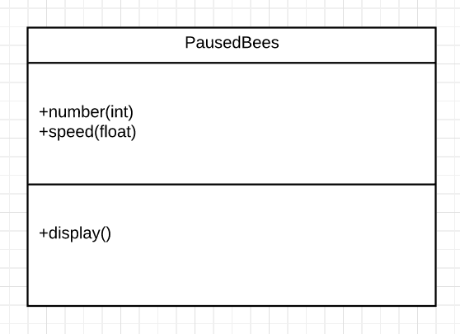

Class:PausedBees

This is an animation of some bees flapping wings when the user pause the game. An object of this class will take two arguments, one is number of bees, and the other is the speed of flapping wings. In the main program, we could decide how many bees we want to show on the screen and how fast they flap wings.